PURPOSE

We tried to keep our database as effective as possible. We categorized our products by type. We tried to keep every feature of our products. We kept these features in the database. We aimed our customers to reach our products in the fastest and most effective way. We have struggled to ensure that our client can reach what he is looking for more effectively.

Our goal is to create a database that can be developed and useful, also a database that can be adapted to our website or sites like ours. Our biggest goal is to bring our shopping website to maximum performance with regular data entries.

PROCESSES WE USED FOR DEVELOPMENT

Firstly, we added lots of items from UNF table randomly.

Then, as a result of normalization operations, we obtained relations as follows.

Product Table

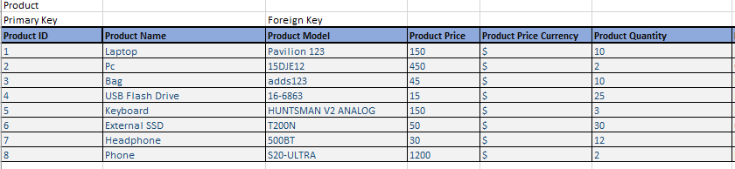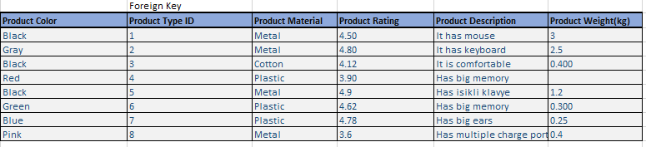

Product Model Table Product Type Table

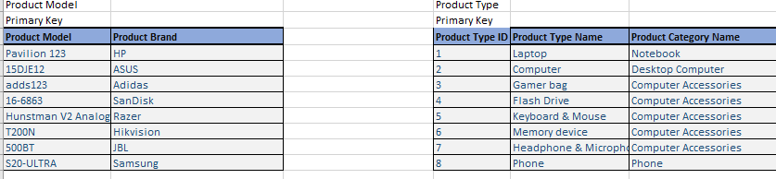

Customer Table

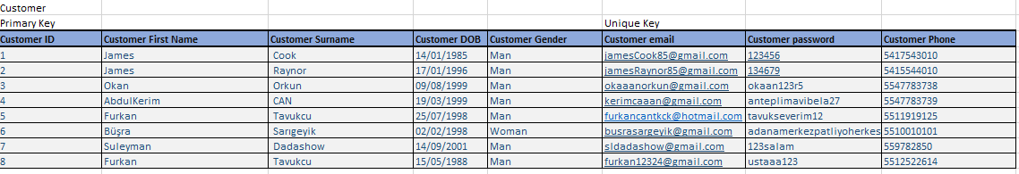

Address Table

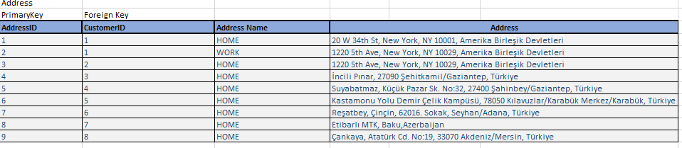

Product Comment Table Cart Table

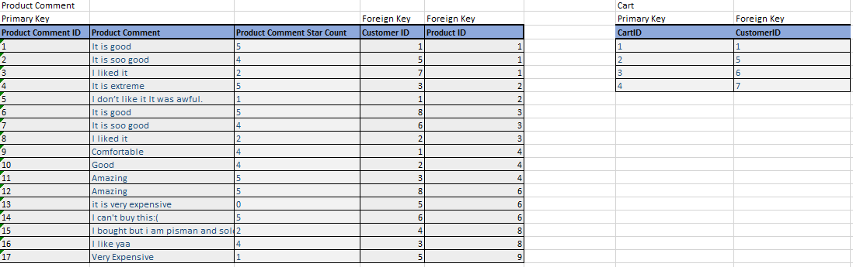

Product In Cart Table

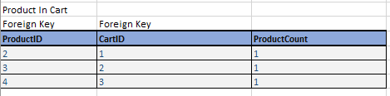

Order Table

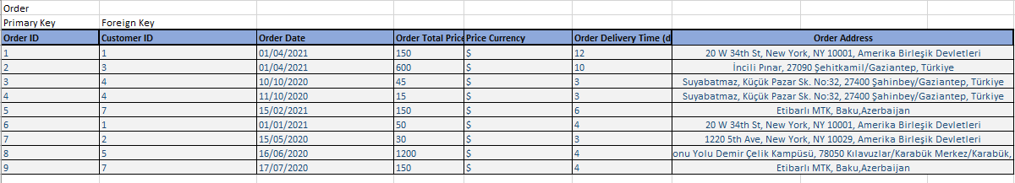

Product Order Relation Table Property Table

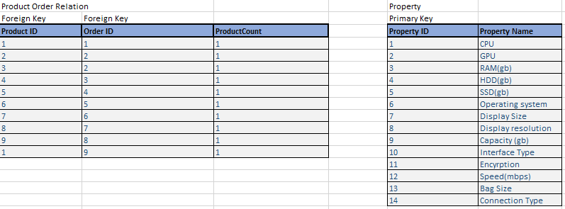

Property Value Table Product Property Table

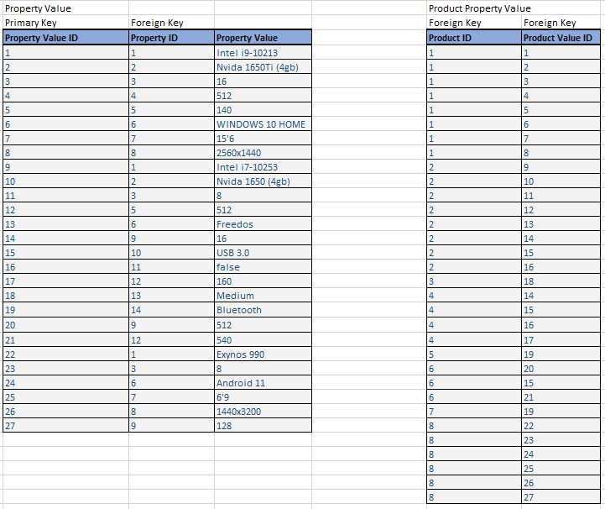

In the E-R diagram, we showed the relationship of the relations with each other as follows.

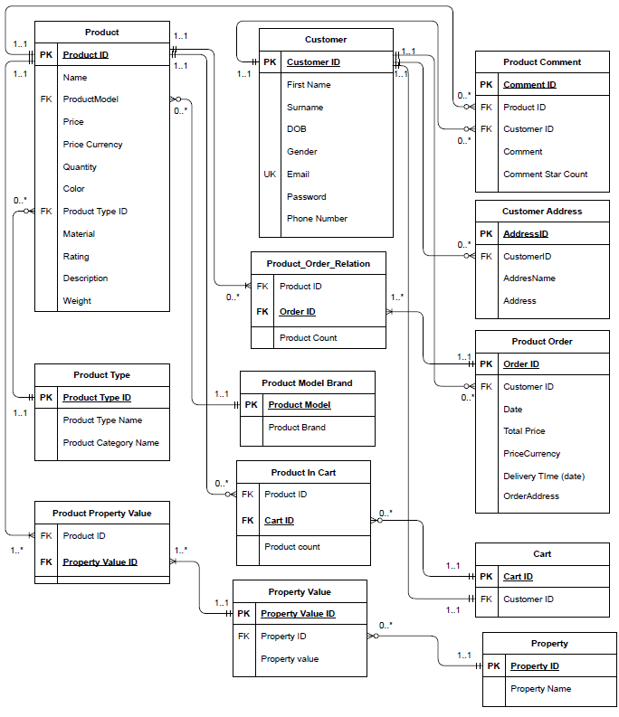

QUERIES

First, to access our data with SQL queries, we wrote our UNF table with SQL query.

And we added our 3NF table to the clipboard by pulling the data from our UNF table.

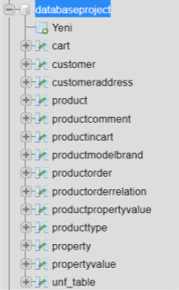

By pulling the data from the 3NF table, we created a view similar to the UNF table.

First Customer Responses

1. List all customers who have ordered a particular product  
     
   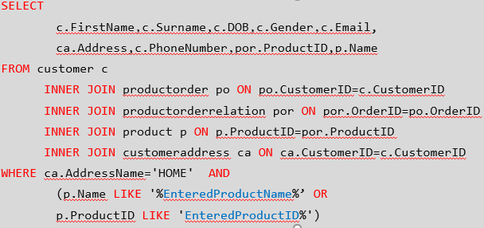
2. Show the maximum, minimum, and average price of all products based on type

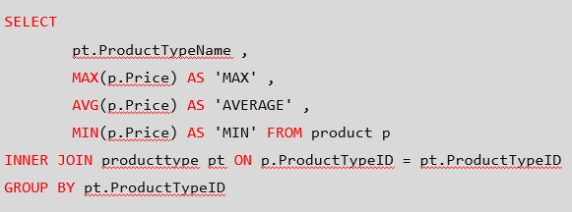

1. Order a product and change the quantity available

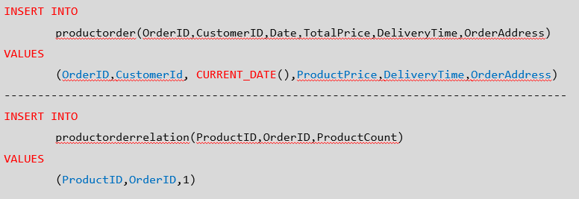

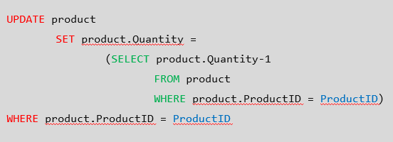

1. Add a product to a customer's cart

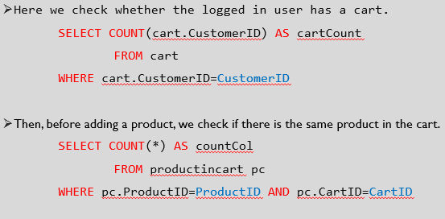

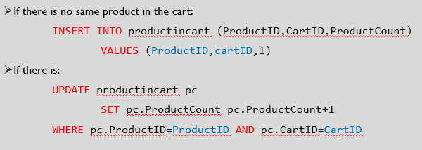

1. Remove a comment

